You can create a virtual env within the CMD prompt.

First you have to :

pip install virtualenv (make sure Python is added to path)

after installation you navigate to the desired location and type in cmd:

“virtualenv envname” this will create a folder with env name containing your VENV.

Eg.

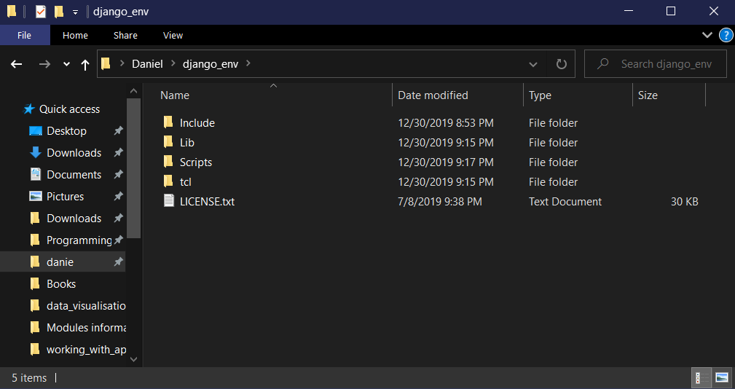

To activate the VENV you have to navigate to **venvname/scripts/activate.bat**

This is a windows .bat file , either click on it or run it trough the cmd prompt after

After you activated your VENV it should look like this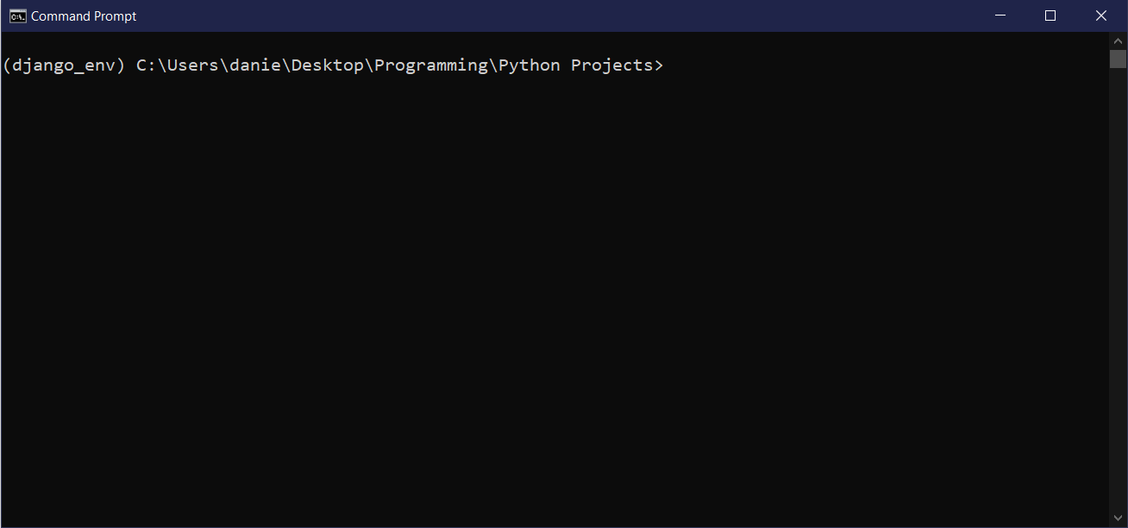

(django_env) tells us that that env is currently activate.

Now we can use pip list to list all the packages installed in the current environment.

pip install packagename – to install new packages

pip uninstall packagename – to uninstall new packages

If you want to exit the VENV than just navigate to envname/scripts/deactivate.bat